Dirty Diesels ruin health!
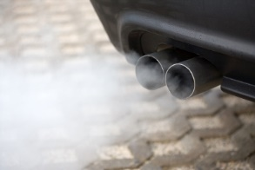
Reading’s air is illegal and dangerous ...
Reading Friends of the Earth’s petition to Reading Borough Council:
“I call for a new air quality action plan to be put in place by 2018 with the necessary resources to cut all pollutant levels to below World Health Organisation guidelines by 2020.”
Please sign petition!
https://tinyurl.com/cleanair4rdg
or see www.readingfoe.org.uk
Dirty Diesels ruin health!
Reading’s air is illegal and dangerous ...
Reading Friends of the Earth’s petition to Reading Borough Council:
“I call for a new air quality action plan to be put in place by 2018 with the necessary resources to cut all pollutant levels to below World Health Organisation guidelines by 2020.”
Please sign petition!
https://tinyurl.com/cleanair4rdg
or see www.readingfoe.org.uk

